Mechanical Overview

Year: 2022 Semester: Fall Team: 08 Project: Hermes

Creation Date: ­September 24, 2022 Last Modified: September 24, 2022

Author: Santiago J. García Delgado Email: [garciads@purdue.edu](mailto:garciads@purdue.edu)

Assignment Evaluation:

|  |  |  |  |  |
| --- | --- | --- | --- | --- |
| **Item** | **Score (0-5)** | **Weight** | **Points** | **Notes** |
| **Assignment-Specific Items** | | | | |
| **Commercial Packaging Analysis 1** |  | x2 |  |  |
| **Commercial Packaging Analysis 2** |  | x2 |  |  |
| **CAD Model Illustrations** |  | x4 |  |  |
| **Project Packaging Specifications** |  | x2 |  |  |
| **PCB Footprint Layout** |  | x2 |  |  |
| **Writing-Specific Items** | | | | |
| **Spelling and Grammar** |  | x2 |  |  |
| **Formatting and Citations** |  | x1 |  |  |
| **Figures and Graphs** |  | x2 |  |  |
| **Technical Writing Style** |  | x3 |  |  |
| **Total Score** |  | | |  |

5: Excellent 4: Good 3: Acceptable 2: Poor 1: Very Poor 0: Not attempted

Comments:

*Comments from the grader will be inserted here.*

1. Commercial Product Packaging

Our product is unlikely to be commercially available in most markets. Retail customers are unlikely to use these products regularly for their intended usage. As a result, we’re only able to show the most relevant products available, with consumer-focused products requiring some modifications required for them to be comparable to our Hermes project. The products are “Martrice 210 Public Safety Thermal Kit” [1] and “Skydio Public Safety Drone” [2]

* 1. Product #1

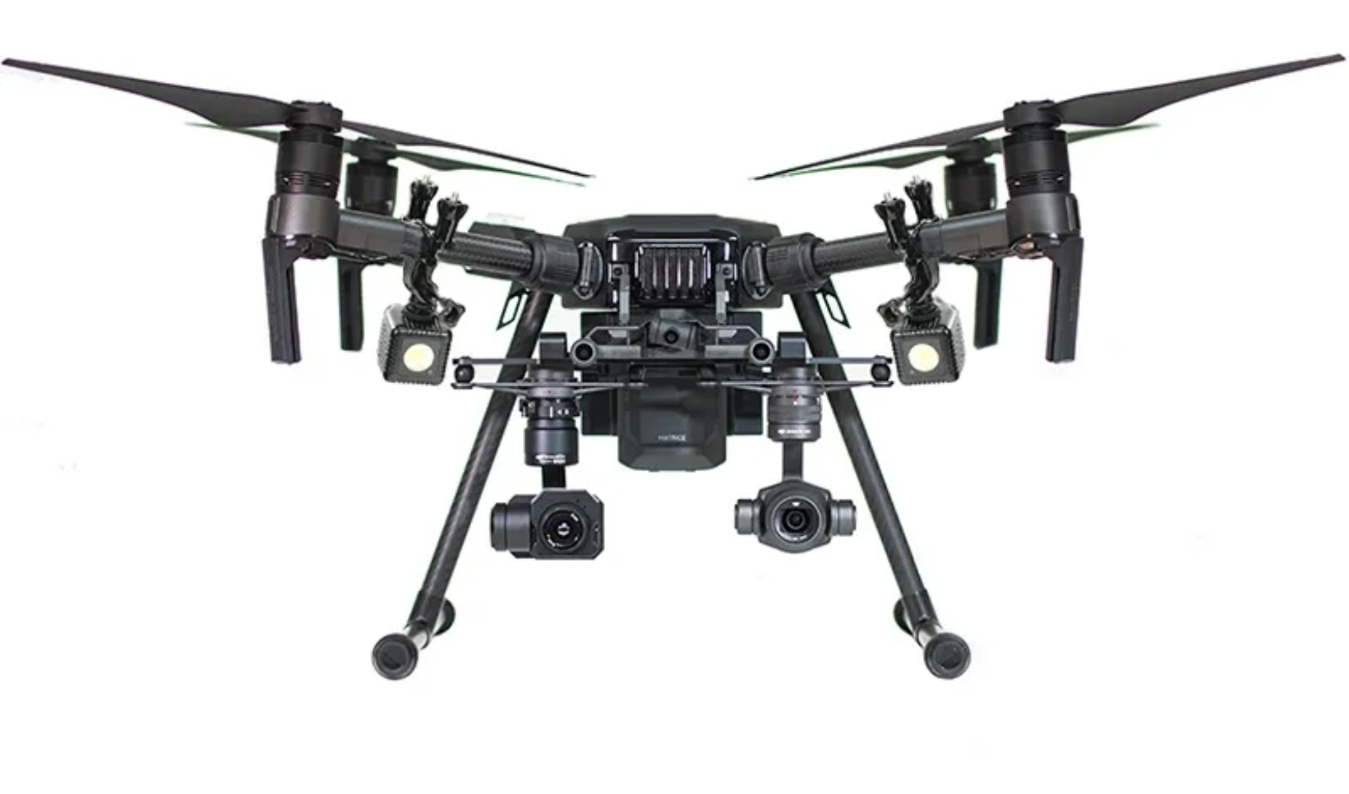

The “Matrice 210 Public Safety Thermal Kit” is packaged within the aircrafts body, the aircraft body has removable blades and landing gear. It has WB37 Intelligent Battery that are detachable and can be recharged independently of the drone, these batteries attach to the back of the drone close to the on/off button of the drone. The drone can be outfitted with different cameras the sky ports at the front of the drone. The two cameras that come with the drone are the XT2, and the Z30. It can be controlled with the accompanying Remote Controller, which also comes with its own rechargeable battery. You can view the camera view with an accompanying crystal sky monitor. The crystal sky monitor can additionally be attached to the front of the remote.

The packaging for the drone is very hefty and very durable, which is the multiple options you have with cameras; batteries and the controller make it very versatile. However, with all these features and modifications this drone can be extremely costly.

Our main drone chassis will have similar features to this drone. It will have an on/off button, replaceable propellers, and batteries, although not rechargeable a stereo camera on the front facing part of the drone.

* 1. Product #2

The “Skydio Public Safety Drone” is packaged within the aircraft body, which comes with additional propellers where any of them break. The drone body has non-foldable arms and several cameras around the body to ensure that in autonomous mode it functions properly. The drone comes with a detachable rechargeable battery, but to recharge it they must be connected to the drone. You also need a very fast micro-SD card. No remote is needed, instead you use your phone with an app to operate the Drone.

The packaging for the drone is light and very portable, however with all its cameras and additional features it’s still very expensive. Another major drawback is its lack of a remote control which leads to a lot of uncomfortable moments for the user.

In our design we decided on a similar build like this with non-foldable arms, similar in size. Because we believe it would lead to the best results when being in autonomous drone. However, unlike this design we decided to use a different controller. And instead of using a phone to view the autonomous camera we utilize a computer.

2.0 Project Packaging Description

It can be noted from Appendix 1, the packaging design will resemble a small drone like the Skydio public safety Drone. The PCB and additional components will be mounted onto the middle section of the body.

The reason for a small and simple design is to keep our drone affordable and so it will be more maneuverable in tight areas. It will have a radio receiver for manual control and LIDAR sensor to avoid crashing, and Pi Camera to be used in autonomous mode for path planning and mapping.

3.0 Sources Cited

[1] Aerial Media Pros. *Matrice 210 Public Safety Thermal Kit* [Online]. Available: <https://www.aerialmediapros.com/matrice-210-first-responder-thermal-kit.html>

[2] Skydio. *Skydio 2+ Starter Kit* [Online]. Available: <https://shop.skydio.com/products/skydio-2-plus>

[3] Phillipp Seidel & Mike Scharf. (Apr 18, 2019). *OpenSource FPV Racing Frame* [Online]. Available: <https://github.com/ps915/source_two>

Appendix 1: CAD Model Illustration

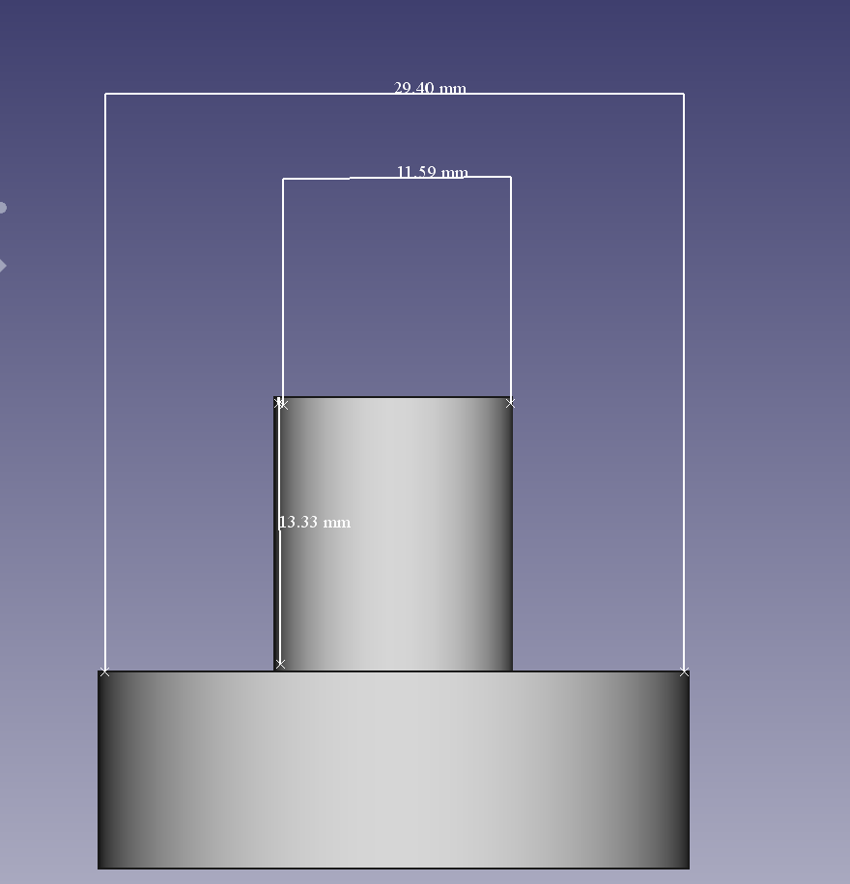

Figure 1: Motor Model

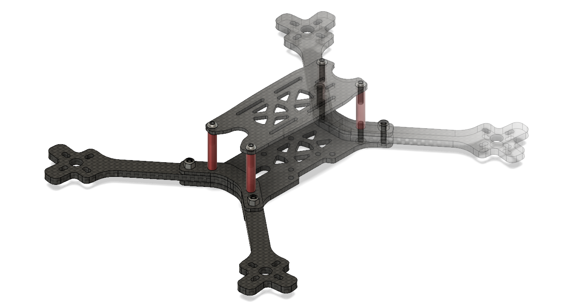

Figure 2: Drone Frame [3]Appendix 2: Project Packaging Specifications

|  |  |  |  |
| --- | --- | --- | --- |
| Material | Weight | Cost | Tools |
| 1 x frame weight | 145.1g | $26.95 | 3-d printer |
| 4 x motor weight | 126.4g | $20.99 | Adhesive |
| 4 x propellers | 4g | $2.00 | Screwdriver |
| Total | 275.5g | $49.94 |  |

Table 1: Materials, tools, weight and cost

Appendix 3: PCB Footprint Layout

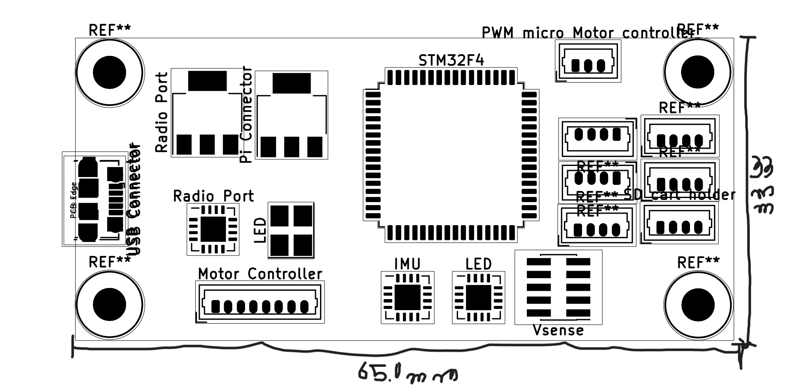

Figure 3: PCB

Dimensions: 33mm x 65.0mm